PHY 102 Modern Physics Final Exam
Date: March 22, 2013 Name: __________________________________

1. Field quanta (12 points)
The Klein-Gordon equation below can be used to describe wave functions of mediating particles involved in fundamental forces such as residual strong force and electromagnetic force.

$$∇^{2}ψ-\frac{1}{c^{2}}\frac{∂^{2}ψ}{∂t^{2}}=\frac{m^{2}c^{2}}{ℏ^{2}}ψ$$

- (3 points) Verify that $ψ_{1}$ shown below is a solution to the Klein-Gordon equation for r > 0.
$$ψ_{1}=-\frac{a^{2}}{r}e^{-r/R} where R=\frac{ℏ}{mc}$$
Note that $∇^{2}=$= $\frac{1}{r^{2}}\frac{∂}{∂r}\left(r^{2}\frac{∂}{∂r}\right)+ \frac{1}{r^{2}sinθ}\frac{∂}{∂θ}\left(sinθ\frac{∂}{∂θ}\right)+ \frac{1}{r^{2}\sin^{2}θ}\frac{∂}{∂ϕ^{2}}$
$${∇^{2}ψ_{1}-\frac{1}{c^{2}}\frac{∂^{2}ψ_{1}}{∂t^{2}}=∇}^{2}ψ_{1}=\frac{1}{r^{2}}\frac{∂}{∂r}\left(r^{2}\frac{∂}{∂r}\right)ψ_{1}=\frac{1}{r^{2}}\frac{∂}{∂r}\left(r^{2}\frac{∂}{∂r}\right)\left(-\frac{a^{2}}{r}e^{- \frac{r}{R}}\right)=\frac{1}{r^{2}}\frac{∂}{∂r}\left(r^{2}( \frac{a^{2}}{r^{2}}e^{- \frac{r}{R}}+\frac{a^{2}}{rR}e^{- \frac{r}{R}})\right)=\frac{1}{r^{2}}\frac{∂}{∂r}\left(\left(a^{2}+\frac{a^{2}r}{R}\right)e^{- \frac{r}{R}}\right)=\frac{1}{r^{2}}\left(\frac{a^{2}}{R}e^{- \frac{r}{R}}-\frac{1}{R}\left(a^{2}+\frac{a^{2}r}{R}\right)e^{- \frac{r}{R}}\right)=\frac{1}{R^{2}}\left(-\frac{a^{2}}{r}e^{-\frac{r}{R}}\right)=\frac{1}{R^{2}}ψ_{1}=\frac{m^{2}c^{2}}{ℏ^{2}}ψ_{1}$$
- (2 points) Under what condition, $ψ_{2}$ below can be a solution to the Klein-Gordon equation?
$$ψ_{2}=-\frac{b^{2}}{r}$$

$${∇^{2}ψ_{2}-\frac{1}{c^{2}}\frac{∂^{2}ψ_{2}}{∂t^{2}}=∇}^{2}ψ_{2}=\frac{1}{r^{2}}\frac{∂}{∂r}\left(r^{2}\frac{∂}{∂r}\right)ψ_{2}=\frac{1}{r^{2}}\frac{∂}{∂r}\left(r^{2}\frac{∂}{∂r}\right)\left(-\frac{b^{2}}{r}\right)= \frac{1}{r^{2}}\frac{∂}{∂r}\left(r^{2}\frac{b^{2}}{r^{2}}\right)=0$$
$$\frac{m^{2}c^{2}}{ℏ^{2}}ψ_{2}can be zero if and only if m=0$$

- (2 points) Pions ($π^{+}, π^{-}, π^{0})$ are mediating particles (field quanta) for the residual strong force between two nucleons. Using uncertainty principle ($∆t∆E ≈ℏ$ ), estimate the mass of pion.

- A particle of energy $∆E$ can exist without violating energy conservation as long as it exists less than $∆t ≈\frac{ℏ}{∆E}.$
- Consider $∆E$ is the energy of the mediating particle created and exchanged when the force is exerted, then $∆E=mc^{2}$
$$∆t ≈\frac{ℏ}{∆E}≈\frac{ℏ}{mc^{2}}$$
- Range ($∆x)$ becomes
$$∆x≈c∆t≈\frac{ℏ}{c}\frac{1}{m}$$

Thus,

$$m≈c∆t≈\frac{ℏ}{c}\frac{1}{∆x}=\frac{1.054572 x {10}^{-34} J s}{(3 x {10}^{8} m/s) (2 x {10}^{-15} m) }=1.76 x {10}^{-28}kg≅200 m_{e}$$

(about 200 times electron mass)

- (2 points) Photons are mediating particles (field quanta) for the electromagnetic force between two charged particles. Which wave function, $ψ_{1}{or ψ}_{2},$ describes pions and which describes photons?

$$ψ_{1} for pions and ψ_{2} for photons$$

(e) (3 points) In at least three aspects, contrast between the residual strong force and the electromagnetic force using $ψ_{1}{and ψ}_{2}$ as well as field quanta characteristics.

(1 point) the potential implied by $ψ_{1}$is a short range one and the potential implied by $ψ_{2}$is a long range one.
(1 point) Pions have mass and photons do not have mass
(1 point) Pions can have charges but photons do not have charges

Extra point: If field quanta have mass, then the associated force is short-ranged. If field quanta do not have mass, then the associated force is long-ranged.

2. Electron Shell Model and Nuclear Shell Model (14 points)
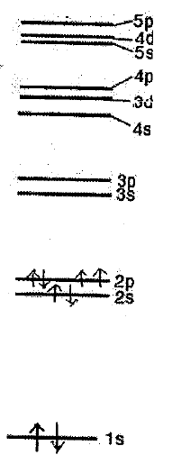
${}_{8}^{16}O$ has 8 protons, 8 neutrons, and 8 electrons.

- (1 point) The atomic energy diagram for ${}_{8}^{16}O$ is shown on the right. Show how the electrons in the ground state of the O atom fill up the electron energy states. Use $↑↓$ for electrons.
See the diagram.

(2 points) Using your energy diagram, is O chemically inert or reactive?

(0.5 point) Chemically reactive

Explain your answer.

(0.5 point) four electrons occupy the 2p energy level in the valence shell (where 2s and 2p levels are clustered).
(0.5 point) The valence shell is not fully occupied and two more electrons need to occupy to make the valence shell full.
(0.5 point) ${}_{8}^{16}O$ will easily gain two electrons from other atoms to have the full valence shell during chemical reactions.

(b) (2 points) On diatomic molecular orbital energy levels drawn below, show how electrons occupy the energy levels for the ground state O₂. For example, when two 2s electrons from two atoms occupying the same $σ$2s molecular orbital state are represented as:

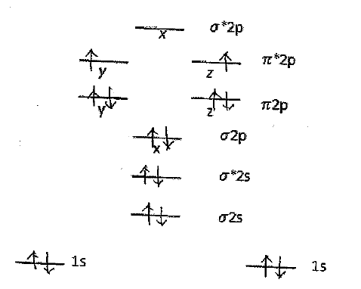
(1 point) Use your diagram to explain how many covalent bonds are possible in $O_{2}.$
Two covalent bonds are possible since there are eight shared electrons engaged in boding states and four shared electrons are engaged in anti bonding states.
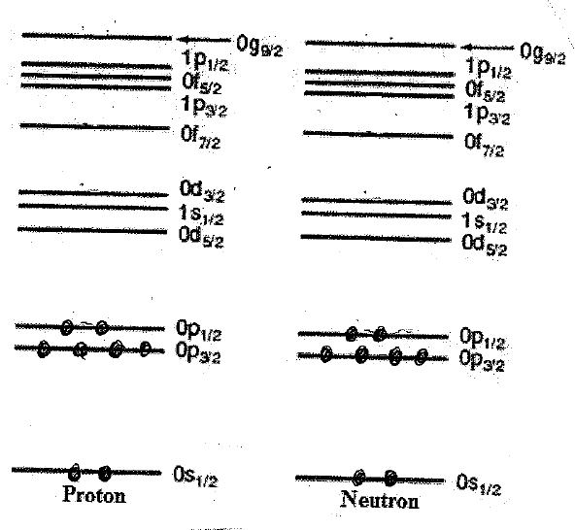
(c) (4 points) Using energy diagrams on the right show how 8 protons and 8 neutrons in the ground state of the O nucleus fill up the energy states. Use • for a nucleon.

(d) (2 points) What would be the nuclear spin for ${}_{8}^{16}O$? zero

Explain your choice.

Both protons and neutrons completely fill up the valence shell. Within the shell, spins of individual protons or neutrons are completely paired up, leading to no net spins.

(e) (2 points) O (Z=8) has 5 isotopes. However, 99.76% of the naturally existing O is ${}_{8}^{16}O.$ Explain why this is the case. Base your reasoning on your energy diagrams.

(1 point) In the nuclear shell model, a nucleus of which outermost shell is fully occupied by nucleons is very stable (known as magic numbers).
(1 point) 8 protons and 8 neutrons completely fill their respective outermost shell, giving a stable arrangement.

3. Nuclear Binding Energy and Decay (18 points)
(a) (2 points) Find the binding energy per nucleon for ${}_{8}^{16}O$ in MeV.
Note that $m_{H}$= 1.007825u; $m_{n}$=1.008665u; $m_{{}_{8}^{16}O}=$15.9949u; $uc^{2}=$931.5 MeV.

$$Binding Energy=\left(Zm_{H}+Nm_{n}-M_{{}_{Z}^{A}X}\right)c^{2}=\left(8 x 1.007825+8 x 1.008665-15.9949\right)uc^{2}=0.13702 x 931.5 MeV=127.63 MeV$$
Binding energy per nucleon$=\frac{Binding energy}{A (=16)}=7.98 MeV$

(b) (2 points) How much energy is required to remove one proton from ${}_{8}^{16}O$?
Note that $m_{{}_{8}^{15}O}$=15.0030u and $m_{{}_{7}^{15}N}$= 15.0001u.

$${}_{8}^{16}O→{}_{7}^{15}N+p$$

Energy needed=${(m}_{{}_{7}^{15}N}+m_{H}-m_{{}_{8}^{16}O}) uc^{2}=\left(15.001+1.007825-15.9949\right)uc^{2}=0.013025 x 931.5 MeV=$ 12.13 MeV

(c) (2 points) How much energy is required to remove one neutron from ${}_{8}^{16}O$?

$${}_{8}^{16}O→{}_{8}^{15}O+n$$

Energy needed=${(m}_{{}_{8}^{15}O}+m_{N}-m_{{}_{8}^{16}O}) uc^{2}=\left(15.0030+1.008665-15.9949\right)uc^{2}=0.016765 x 931.5 MeV=15.62 MeV$

(d) (1 point) Which nucleus will decay naturally? __x_ ${}_{8}^{15}O$ ____ ${}_{7}^{15}N$

(1 point) Represent the decay process.
$${}_{8}^{15}O→{}_{7}^{15}N+{}_{+1}^{0}{β^{+}+ν}$$
(2 points) Explain how that decay process can stabilize the affected nucleus.

Removing a proton from the nucleus is easier because doing so reduces repulsive Coulomb interactions.
The energy required to remove one neutron is higher than the energy required to remove one proton from the ${}_{8}^{16}O$. Thus, ${}_{7}^{15}N$ is more stable than ${}_{8}^{15}O.$
Beta plus decay allows to change one proton to one neutron, reducing positive charge.

(e) (2 points) The isotope ${}_{90}^{232}{Th}$ successively undergoes six alpha decays and four beta minus decays. What is the resulting isotope? Show your work.
Alpha decay:
$${}_{Z}^{A}{X\left(parent\right)→ }{}_{Z-2}^{A-4}{Y\left(daughter\right)+ }{}_{2}^{4}{He}$$

  - $Z_{daughter}=Z_{parent}-2$
  - $N_{daughter}=N_{parent}-2$
  - $A_{daughter}=A_{parent}-4$

Beta (-) decay:
$${}_{Z}^{A}{X\left(parent\right)→ }{}_{Z+1}^{A}{Y\left(daughter\right)+ }{}_{-1}^{0}{β^{-}+\overline{ν}}$$
  - $Z_{daughter}=Z_{parent}+1$
  - $N_{daughter}=N_{parent}-1$
  - $A_{daughter}=A_{parent}$

After eight alpha decays and six beta minus decays, the resulting nucleus should have

$$Z_{daughter}=90-6 x 2+4 x 1=82$$
$$A_{daughter}=232-6 x 4+4 x 0=208$$
Thus
$${}_{82}^{208}{Pb}$$

(f) (6 points) The isotope ${}_{4}^{7}{Be}$ can decay into ${}_{3}^{7}{Li}$ through $β^{+}$decay or electron capture process. Express each decay process and calculate released energy. Note that mass of ${}_{4}^{7}{Be}$ is 7.016928 u and that of ${}_{3}^{7}{Li}$ is 7.016003 u and electron mass is 0.0005486u.

(1 point) $β^{+}$ decay process:
$${}_{4}^{7}{Be}→{}_{3}^{7}{Li}+{}_{+1}^{0}{β^{+}+ν}$$
(1 point) Released energy during the $β^{+}$ decay process =

$$Q=\left(m_{parent}-m_{daughter}-2m_{electron}\right)c^{2}$$
$$=\left(7.016928-7.016003-2 x 0.0005486\right)uc^{2}$$
$$=-0.00017x 931.5 MeV=-0.1604 MeV$$
(1 point) Electron capture process:
$${}_{4}^{7}{Be}+{}_{-1}^{0}{β^{-}}→{}_{3}^{7}{Li}+ν$$
(1 point) Released energy during the electron capture process =

$$Q=\left(m_{parent}-m_{daughter}\right)c^{2}=\left(7.016928-7.016003\right)uc^{2}$$
$$=0.000925 x 931.5=0.8616 MeV$$

(1 point) Which decay process is preferred? ___ $β^{+}$ decay _x_ electron capture

Explain your answer.

(1 point) electron capture is energetically preferred. Energy is released in the electron capture but energy is absorbed in the beta plus decay.
(Extra point) In beta plus decay, the mass of the parent nucleus must be at least one electron mass greater than the daughter. However, in the electron capture, the parent nucleus can be less than one electron mass than the daughter.

4. Particle decays and conservation rules (12 points; 3 points each)
Indicate whether or not the proposed decay is possible and explain why. Consider mass, spin angular momentum, strangeness, charge, Baryon number and Lepton number before and after the decay. If the decay process is possible, draw a Feynman Diagram for the process.

(a) $Ξ^{-}→Λ^{0}+π^{-}$ x_ possible __ impossible

Explain: possible through weak interaction involving $W^{-}$

 | Before | After
 | $$Ξ^{-}$$ | $$Λ^{0}$$ | $$π^{-}$$
Mass | 1321 | 1116 | 140
Charge | -1 | 0 | -1
Spin | ½ | 1/2 | 0
Strageness | -2 | -1 | 0
Baryon Number | 1 | 1 | 0
Lepton Number | 0 | 0 | 0

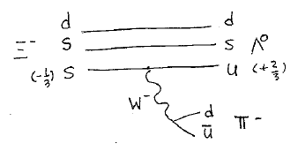
(b) $Λ^{0}→n+π^{-}$ __ possible _x impossible

Explain: Impossible because charge and strangeness are not conserved.

 | Before | After
 | $$Λ^{0}$$ | n | $$π^{-}$$
Mass | 1116 | 940 | 140
Charge | 0 | 0 | -1
Spin | 1/2 | ½ | 0
Strageness | -1 | 0 | 0
Baryon Number | 1 | 1 | 0
Lepton Number | 0 | 0 | 0

(c) $π^{-}+p→ π^{0}+n$ _x_ possible __ impossible

Explain

 | Before |  | After
 | $$π^{-}$$ | p | $$π^{0}$$ | n
Mass | 140 | 938 | 135 | 940
Charge | -1 | +1 | 0 | 0
Spin | 0 | ½ | 0 | ½
Strageness | 0 | 0 | 0 | 0
Baryon Number | 0 | 1 | 0 | 1
Lepton Number | 0 | 0 | 0 | 0

(d) $Σ^{0}→ Λ^{0}+γ$ _x_ possible __ impossible

Explain

 | Before | After
 | $$Σ^{0}$$ | $$Λ^{0}$$ | $$γ$$
Mass | 1193 | 1116 | 0
Charge | 0 | 0 | 0
Spin | 1/2 | 1/2 | 1
Strageness | -1 | -1 | 0
Baryon Number | 1 | 1 | 0
Lepton Number-e | 0 | 0 | 0

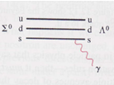
5. Schrodinger Equations (18 points)
Construct a diagram for each of the four systems below. Label the diagram for proton, electron, nucleus and their charges and distances among them. Then, write a Schrodinger Equation for each system as completely as possible.

(a) (3 points) Hydrogen atom (H) consisting of one proton (+e) and one electron (-e) in 3d

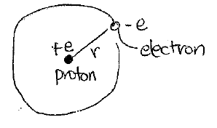
$\frac{-ℏ^{2}}{2m} ∇^{2 }ψ \left(\vec{r}\right)-\frac{1}{4πε_{0}} \frac{e^{2}}{r}$ $ψ \left(\vec{r}\right)$= $E ψ(\vec{r})$

(b) (3 points) Hydrogen molecular ion ($H_{2}^{+}$) consisting of two separate protons (+e) and one electron (-e) in 3d

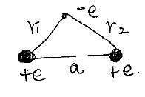$\frac{-ℏ^{2}}{2m} ∇^{2 }ψ \left(\vec{r}\right)-\frac{1}{4πε_{0}}( \frac{e^{2}}{r_{1}}+\frac{e^{2}}{r_{2}})$ $ψ \left(\vec{r}\right)$= $E ψ(\vec{r})$

(c) (3 points) Helium ion (He⁺) consisting of He nucleus (+2e) and one electron (-e) in 3d

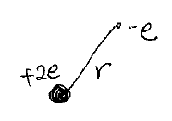

$$-\frac{ℏ^{2}}{2m}∇^{2}ψ\left(\vec{r}\right)-\frac{1}{4πε_{0}}\frac{2e^{2}}{r}ψ\left(\vec{r}\right)=Eψ\left(\vec{r}\right)$$

(d) (3 points) He atom (He) consisting of He nucleus (+2e) and two electrons in 3d

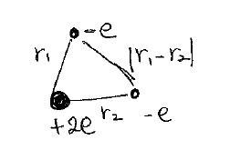

$$\frac{ℏ^{2}}{2m}{∇_{1}}^{2}ψ\left(\vec{r_{1}}, \vec{r_{2}}\right)-\frac{ℏ^{2}}{2m}{∇_{2}}^{2}ψ\left(\vec{r_{1}}, \vec{r_{2}}\right)-\frac{1}{4πε_{0}}[\frac{2e^{2}}{\left|\vec{r_{1}}\right|}+\frac{2e^{2}}{\left|\vec{r_{2}}\right|}-\frac{e^{2}}{\left|\vec{r_{1}}-\vec{r_{2}}\right|}]ψ\left(\vec{r_{1}}, \vec{r_{2}}\right)=Eψ\left(\vec{r_{1}}, \vec{r_{2}}\right)$$

(e) (2 points) Rank these four systems in terms of the amount of energy necessary to remove one electron from the system: (1: largest, 4: smallest)

_4_ Hydrogen atom
_3_ Hydrogen molecular ion
_1_ Helium ion
_2_ Helium atom

(4 points) Explain your ranking. In your explanation, use theory as well as actual estimates.

- Hydrogen atom = -13.6 eV
- Hydrogen molecular ion.
Electrons in the hydrogen molecule will fill up the diatomic molecular energy states. Since electrons in the hydrogen molecule will be engaged in a sigma bonding state which is slightly lower than atomic 1s energy state. This means that the energy will be slightly lower than -13.6 eV.
- Helium ion can be treated as a hydrogen like atom. That is
$$E_{n}=-Z^{2}13.6 eV=-4x13.6 eV=-54.4 eV$$

- Helium atom
The Helium atom has two electrons which are in the 1s orbital. As both electrons move on the same orbital, an electron will feel the reduced positive charge of the nucleus as it is screened by the other electron. When removing the second electron after the first one, then the second electron sees the full positive charge of the nucleus. Therefore, the energy required to remove the first electron is less (in fact about 24.4 eV) than the energy required to remove the second electron (54.4 eV). See Figure 8.16 on p.315 Textbook by Randy Harris.

6. True/False Questions (16 points; 2 points each; 0.5 point for claim 1.5 points for explanation)
Determine whether each of the following statements is true or false. Then, briefly explain your answer.

- All interactions satisfy the same conservation rules. __ True __x_ False
Explain.

(1.5 points) Weak interactions do not conserve strangeness, C (charge conjugation), P (parity inversion) or T (time reversal).

(0.5 point extra) Weak interactions however conserve CPT.

(b) Spontaneous fusion reactions cannot occur on Earth. _x__ True ___ False
Explain.

(1 point) Nuclei are positively charged and must be forced together. They may well be capable of fusing via the short-range strong interaction, but they need to overcome their long-range Coulomb repulsion.
(0.5 point) High temperature and high density can increase the chance of fusion such as stars. These conditions are impossible to be created naturally on Earth.

(c) Nuclear spin does not increase according to the number of nucleons in the nucleus.
_x__ True ___ False
Explain

(1 point) In a closed shell, fermions occupy all available states where their spins are paired up, leading to the zero total spin angular momentum from the fermions in the closed shell.
(1 point) Only the fermions at the unfilled shell contribute to the total spin angular momentum. Thus the total nuclear spin consists of the spin of protons and the spin of neutrons in the unfilled shell.
(extra 0.5 point) Nuclear spins in the same energy state tend to pair up, thus the nuclear spin of the even-number nucleons is zero.

(d) No stable bounding states exist for two nucleon systems. __ True _x__ False
Explain

(0.5 point) only the proton-neutron pair forms a bound state known as a deuteron. Proton-proton or neutron-neutron do not stick together.
(1 point) the internucleon attraction is spin-dependent and it gets stronger when spins are aligned.
(0.5 point) protons and neutrons separately fill up their energy states.
(1 point) due to the exclusion principle, only proton-neutron pair can have aligned spins.

(e) Any electrons in a superconducting material can form Cooper pairs. __ True _x_ False
Explain.
(0.8 point) Only the electrons near the Fermi surface can participate in Cooper Pairs to exchange phonons with the crystal. (0.7 point) Electrons in deep inside the Fermi sea do not have energy states available for them to do the phonon exchange with the crystal.

(f) Energy band shapes of the same solid crystal change according to the distance between ions comprising the crystal. _x_ True ___ False
Explain.
(1 point) The extent of spreading depends on how much overlap there would be between the wave functions of adjacent atoms.
(0.5 point) The bandwidth depends on the atomic spacing, increasing as a decreases.
(g) Energy band shapes do not depend on the size of the crystal. _x_ True ___ False
Explain.
(1 point) The location of each energy band of the solid crystal is associated with one of the atomic energy levels and the bandwidth depends on the atomic spacing.
(0.5 point) The number of allowed energy levels within each band depends on the number of atoms, but the energy band is essentially continuum because N is so large.
(h) Differences among Boltzman, Fermi-Dirac, and Bose-Einstein distributions are clear across all temperature ranges. __ True __x_ False
Explain.
(0.5 point) differences among three types of distributions become clear at low temperatures (and they are not much different in high temperatures)
(0.5 point each for describing each distribution behavior) at low temperatures, the occupation number for the Fermi-Dirac distribution becomes 1; the occupation numbers of Bose-Einstein and Boltzmann distributions can be really high though the occupation number of the Boltzmann distribution is higher than that of the Bose-Einstein distribution at low energy states.

Extra I (8 points)
Unsӧld’s theorem states that, for any value of the orbital quantum number l, the probability densities summed over all possible states from $m_{l}= -l to m_{l}= +l$yield a constant independent of angles $θ or ϕ$, that is
$$\sum_{m_{l}= -l}^{l}{{|Θ_{l{,m}_{l}}|}^{2}{|Φ_{m_{l}}|}^{2}=Constant}$$
- (6 points) Verify Unsӧld’s theorem for $l=1.$
Where
$$l=1, {m_{l}=0, Θ}_{10}= \frac{\sqrt{6}}{2}cosθ , Φ_{0}=\frac{1}{\sqrt{2π}}$$
$$l=1, {m_{l}=±1, Θ}_{1±1}= \frac{\sqrt{3}}{2}sinθ , Φ_{±1}=\frac{1}{\sqrt{2π}}e^{±iϕ}$$

For $l=1,$
$$\sum_{m_{l}= -1}^{1}{{\left|Θ_{1{,m}_{l}}\right|}^{2}{\left|Φ_{m_{l}}\right|}^{2}=} {|{{Θ_{1-1}|}^{2}{\left|Φ_{-1}\right|}^{2}+|Θ}_{10}|}^{2}{{|Φ}_{0}|}^{2}+{{|Θ}_{11}|}^{2}{{|Φ}_{1}|}^{2}=$$

$=\frac{3}{8π}\sin^{2}θ+\frac{3}{4π}\cos^{2}θ$ +$\frac{3}{8π}\sin^{2}θ$ = $\frac{3}{4π} (\sin^{2}θ$+$\cos^{2}θ)= \frac{3}{4π}=constant$

- (2 points) Using this theorem, explain the charge distribution of the Ne atom.

(1 point) The electric charge distribution of the closed shell is isotropic, meaning it has a spherical symmetry – independent of directions.
(0.5 point) Note that it will have dependence on the radius.
(0.5 point) Electrons in the Ne atom fills up l=1 states, leading to constant electron charge that can compensate the charge of the nucleus (shielding).

